**Project Requirement and Specification**

**On**

**Expenditure Management System**

**(CSE IV SEMESTER MINI PROJECT REPORT)**

**2021-2022**



Submitted to: Submitted by:

Dr. Prateek Srivastava Name: Pranjali Kothari

Associate Professor University Roll. No.: 2018554

GEHU, D. Dun Class Roll No./Section: 43/B

**DEPARTMENT OF COMPUTER SCIENCE AND ENGINEERING**

## GRAPHIC ERA HILL UNIVERSITY, DEHRADUN

**CERTIFICATE**

Certified that Ms. Pranjali Kothari(Roll No. : 2018554) has developed mini project on **“Expenditure Management System”** for the CSE IV Semester Mini Project Lab in Graphic Era Hill University, Dehradun. The project carried out by student is their own work as best of my knowledge.

Date : 14th July 2022

Dr. Prateek Srivastava

Class Co-ordinator

CSE-B-IV-SEM

(CSE Department)

GEHU Dehradun

**ACKNOWLEDGMENT**

We would like to express our gratitude to The Almighty, the most beneficent and the most merciful, for completion of the project.

We wish to thank our parents for their continous support and encourgement. We also wish to thank them for providing us with the opportunity to reach this far in our studies.

We would like to thank particularly our project Co-ordinator Dr. Prateek Srivastava for his patience, support and encourgement throughout the completion of this project and having faith in us.

We also acknowledgement them who help us in develeloping the project.

At last but not the least we greatly indebted to all other persons who directly or indirectly helped us during this work.

**Pranjali Kothari**

**Roll No. : 2018554**

**CSE-B-IV-Sem**

**Session : 2021-2022**

**GEHU, Dehradun**

**Table of Content**

1. Introduction
2. Abstract of the Project
3. Objective of the Project
4. Functionalities provided in the Project
5. Requirements of the Project
6. Output
7. Conclusion
8. References

**INTRODUCTION**

The “Expenditure Management System” has been developed to override the problems prevailing in the practicing manual system.Moreover this system is designed for the particular need of the company to carry out operations in a smooth and effective manner.

The application is reduced as much as possible to avoid errors while entering the data. It also provides error message while entering invalid data. No formal knowledge is needed for the user to use this system. Thus by this all it proves it is user-friendly. Expenditure Management System, as described above, can lead to error free, secure, reliable and fast management system. It can assist the user to concentrate on the record keeping. Thus it will help organization in better utilization of resources.

Every organization, whether big or small, has challenges to overcome and managing the information of Category, Expense, User, Payment, Registration. Every Expenditure Management System have different Expenditure needs, therefore we design exclusive employee management sysytems that are adopted to your marginal requirements.

**Abstract of the Project Expenditure Management System**

The purpose of Expenditure Management System is to automate the existing manual system by the help of computerized equipments and full-fledged computer software, fulfilling their requirements, so that their valuable data/information can be stored for a longer period with easy acccesing and manipulation of the same. The required software and hardware are easily available and easy to work with.

Expenditure Management System, as described above, can lead to error free, secure, relaibel and fast management system. It can assist the user to concentrate on their other activities rather to concentrate on the record keeping. Thus it will help organization in better utilization of resources. The organization can maintain computerized records without redundant entries. That means that one need not be distracted by information that is not relevant, while being able to reach the information.

The aim is to automate its existing manual system by the help of computerized equipments and full-fledged computer software, fulfilling their requirements, so that their valuable data/information can be stored for a longer period with easy accesing and manipulation of the same. Basically the project describes how to manage for good performance and better services for the clients.

**Objective of Project on Expenditure Management System**

The main objective of the Project on Expenditure Management System is to manage the details of Expense, Category, Type, User, Registration. It manages all the information about Expense, Payment, Registration, etc. The project is totally built at administrative end and thus only the administrator is guranteed the access. The purpose of the project is to build an application program to reduce the manual work for managing the expenses. It tracks all the details about the expenses of the user.

**Functionalities provided by Expense Management System :**

* Shows Account Balance
* Show Total Income
* Show Total Expense
* History
* Add New Transaction
* Delete a Transaction

**REQUIREMENTS OF THE PROJECT**

**HARDWARE REQUIREMENTS**

DEVICE SPECIFICATIONS

* Processor: Intel®Core ™ i5-8265U CPU @ 1.60GHz 1.80Ghz
* System: 64-bit operating system, x64- based processor
* Installed Ram : 8.00 GB

WINDOWS SPECIFICATIONS

* Edition: Windows 10 Home Single Language
* Version: 2004
* OS Build: 19041.508

**SOFTWARE REQUIREMENTS**

* HTML
* CSS
* Javascript

**HTML**

HTML stands for Hypertext Markup Language. It is used to design the front-end portion of web pages using a markup language. HTML is the combination of Hypertext and Markup language. Hypertext defines the link between the web pages. The markup language is used to define the text documentation within thetag which defines the structure of web pages. Web browsers can read HTML files and render them into visible or audible web pages. HTML describes the structure of a website semantically along with cues for presentation, making it a markup language, rather than a programming language. It is written in the form of HTML elemnets consisting of tags enclosed in anglular brackets.

**CSS**

Cascading Style Sheets fondly referred to as CSS is a simply designed language intended to simplify the process of making web pages presentable. CSS allows you to apply styles to web pages. More importantly, CSS enables you to do this independent of the HTML that makes up each web page.

**Javascript**

JavaScript is a famous scripting language used to create magic on the sites to make the site interactive for the user. It is used to enhance the functionality of a website to run cool games and web-based software. JavaScript (js) is a light-weight object-oriented programming language which is used by several websites for scripting the webpages. It is an interpreted, full-fledged programming language that enables dynamic interactivity on websites when applied to an HTML document. With JavaScript, users can build modern web applications to interact directly without reloading the page every time.

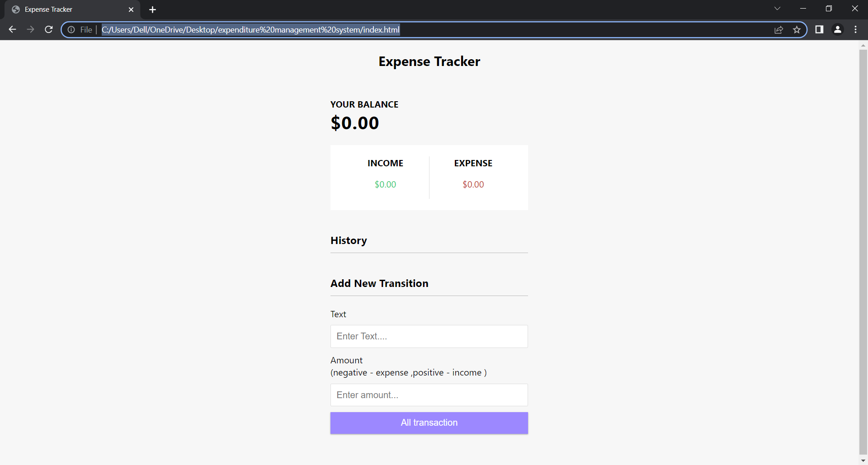**OUTPUT**

**CONCLUSION**

Our project is only a humble venture to satisfy the needs to manage their project work. Several user friendly coding have also adopted. This package shall prove to be a powerful package in satisfying all the requirements. The objective of software planning is to provide a frame work that enables the manger to make reasonable estimates made within a limited time frame at the begning of the software project and should be updated regularly as the project progesses.

**REFERENCES**

* <https://developer.mozilla.org/en-US/docs/Web/JavaScript>
* <https://www.freeprojectz.com/project-report/7447>
* <https://www.geeksforgeeks.org/adding-html-entities-using-css-content/?ref=lbp>
* <https://www.javatpoint.com/javascript-tutorial>
* <https://www.udemy.com/course/css-basics-to-advanced/>